|  |  |
| --- | --- |
| Mata Kuliah | : Pengembangan Aplikasi Web |
| Nama | : Rizki Ardian Samudra |
| NIM | : 210411100179 |
| Kelas | : IF 3D |

**Laporan Output Pertemuan 5**

**CREATE** **DATABASE** pertemuan_5

**CREATE** **TABLE** tbl_mhs(

id_mhs **INT**,

id_prodi **INT**,

nama_mhs **VARCHAR**(40),

alamat_mhs **VARCHAR**(100)

)

**CREATE** **TABLE** tbl_prodi(

id_prodi **INT**,

nama_prodi **VARCHAR**(40),

status_prodi **VARCHAR**(20)

)

**INSERT** **INTO** tbl_prodi

**VALUES**(1,"Teknik Informatika", "aktif"),

(2, "Sistem Informasi", "non aktif"),

(3, "Teknik Industri", "aktif"),

(4, "Teknik Mesin", "non aktif"),

(5, "Teknik Elektro", "aktif")

**SELECT** * **FROM** tbl_prodi

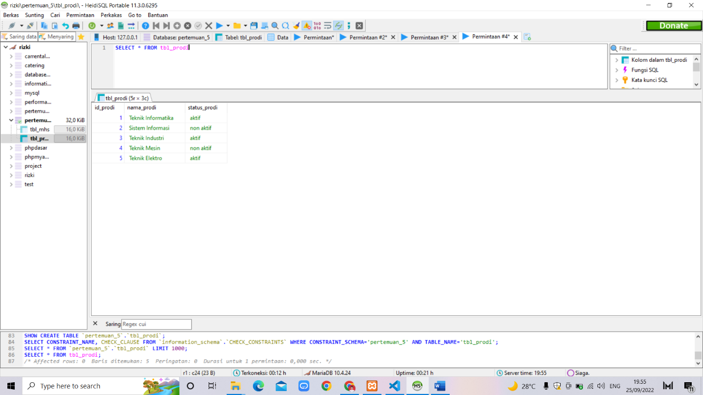

**INSERT** **INTO** tbl_mhs

**VALUES** (1,1,"Rizki","Tuban"),

(2,1,"Ahmad","Bangkalan"),

(3,2,"Hilmi","Boojonegoro"),

(4,3,"Ardian","Sidoarjo"),

(5,4,"Irfan","Lamongan"),

(6,5,"Sania","Surabaya")

**SELECT** * **FROM** tbl_mhs

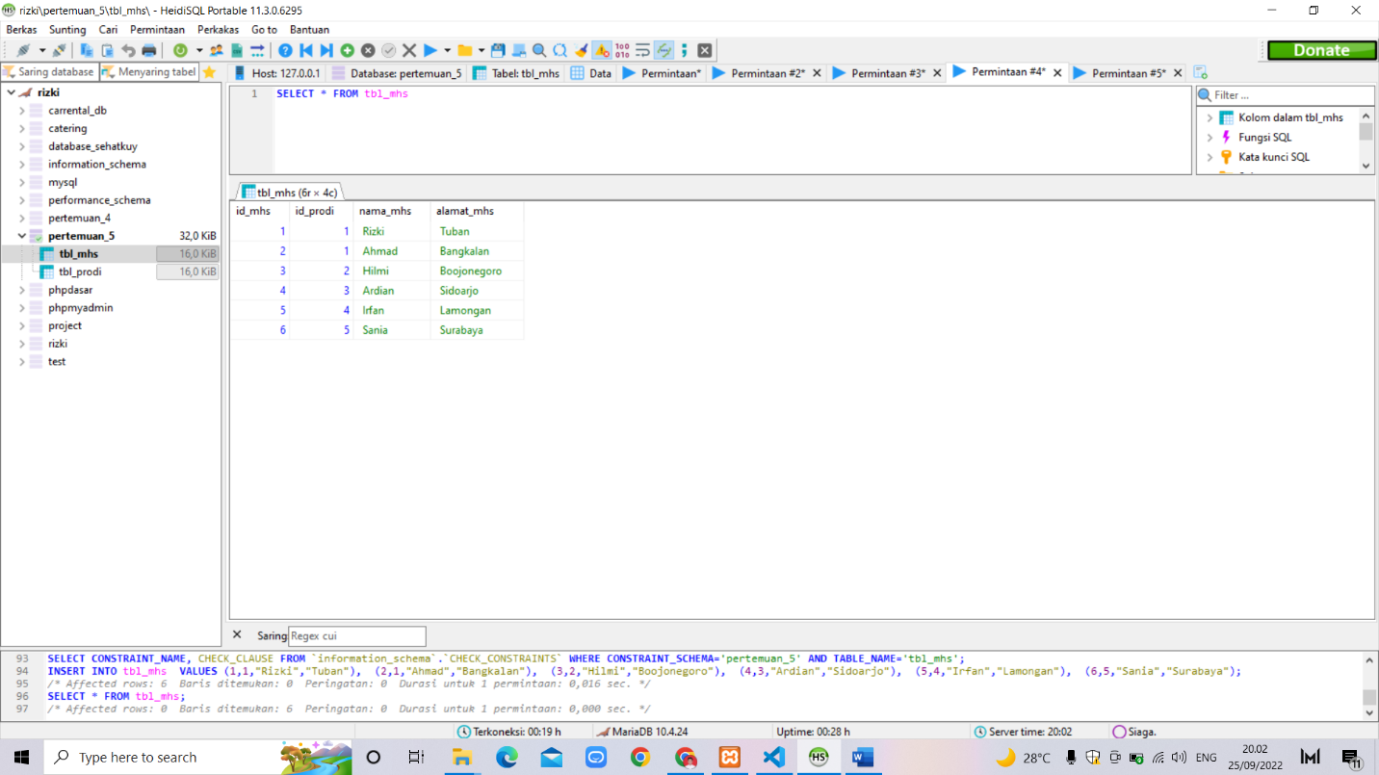

**SELECT** * **FROM** tbl_mhs **WHERE** alamat_mhs="Tuban"

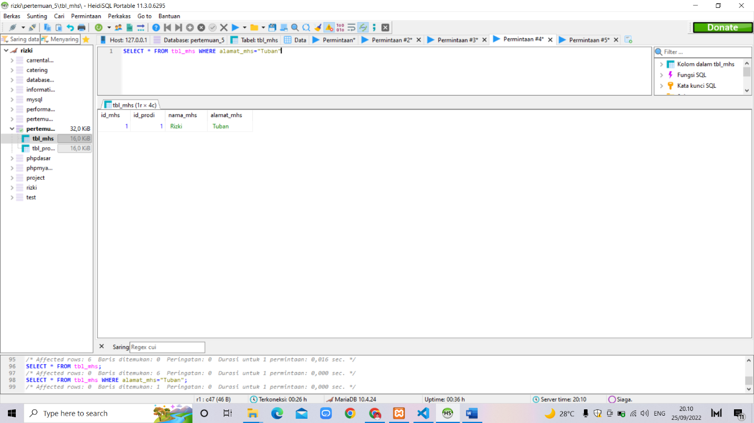

**SELECT** * **FROM** tbl_mhs **WHERE** id_prodi=1

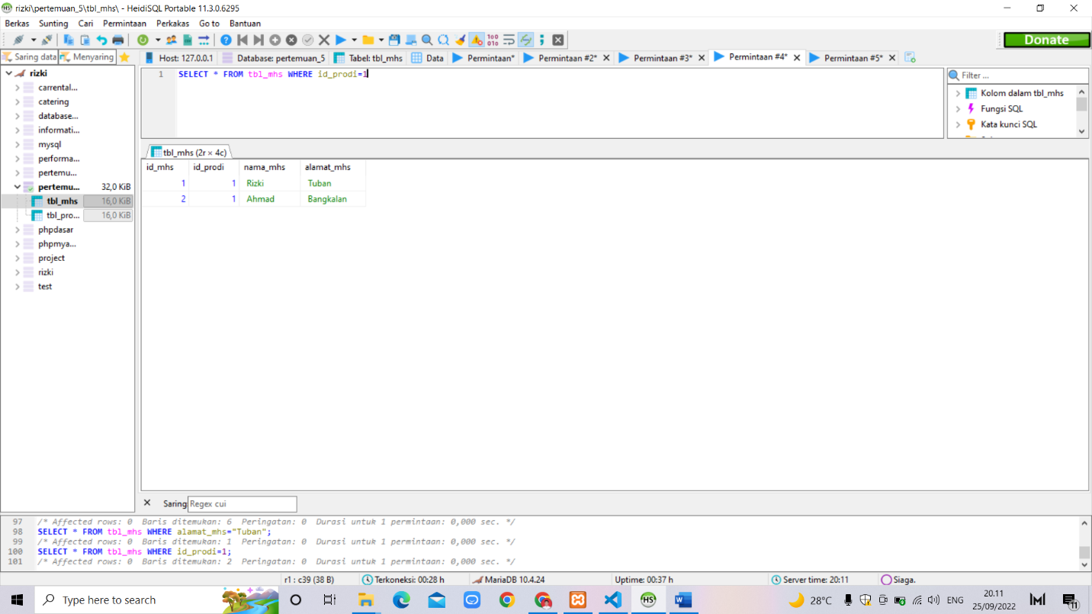

**SELECT** * **FROM** tbl_mhs **ORDER** **BY** nama_mhs

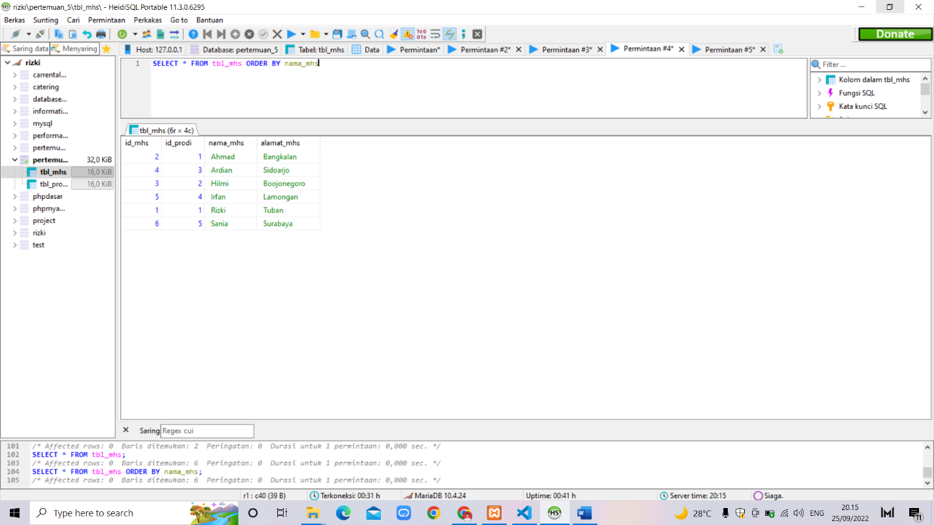

**SELECT** * **FROM** tbl_mhs **ORDER** **BY** alamat_mhs **DESC**

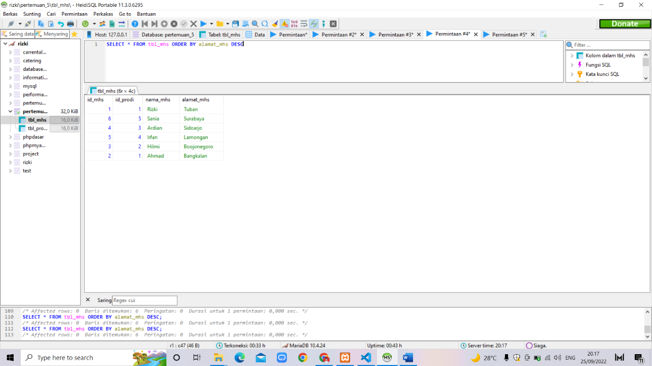

**SELECT** nama_mhs,alamat_mhs

**FROM** tbl_mhs

**WHERE** id_prodi=1

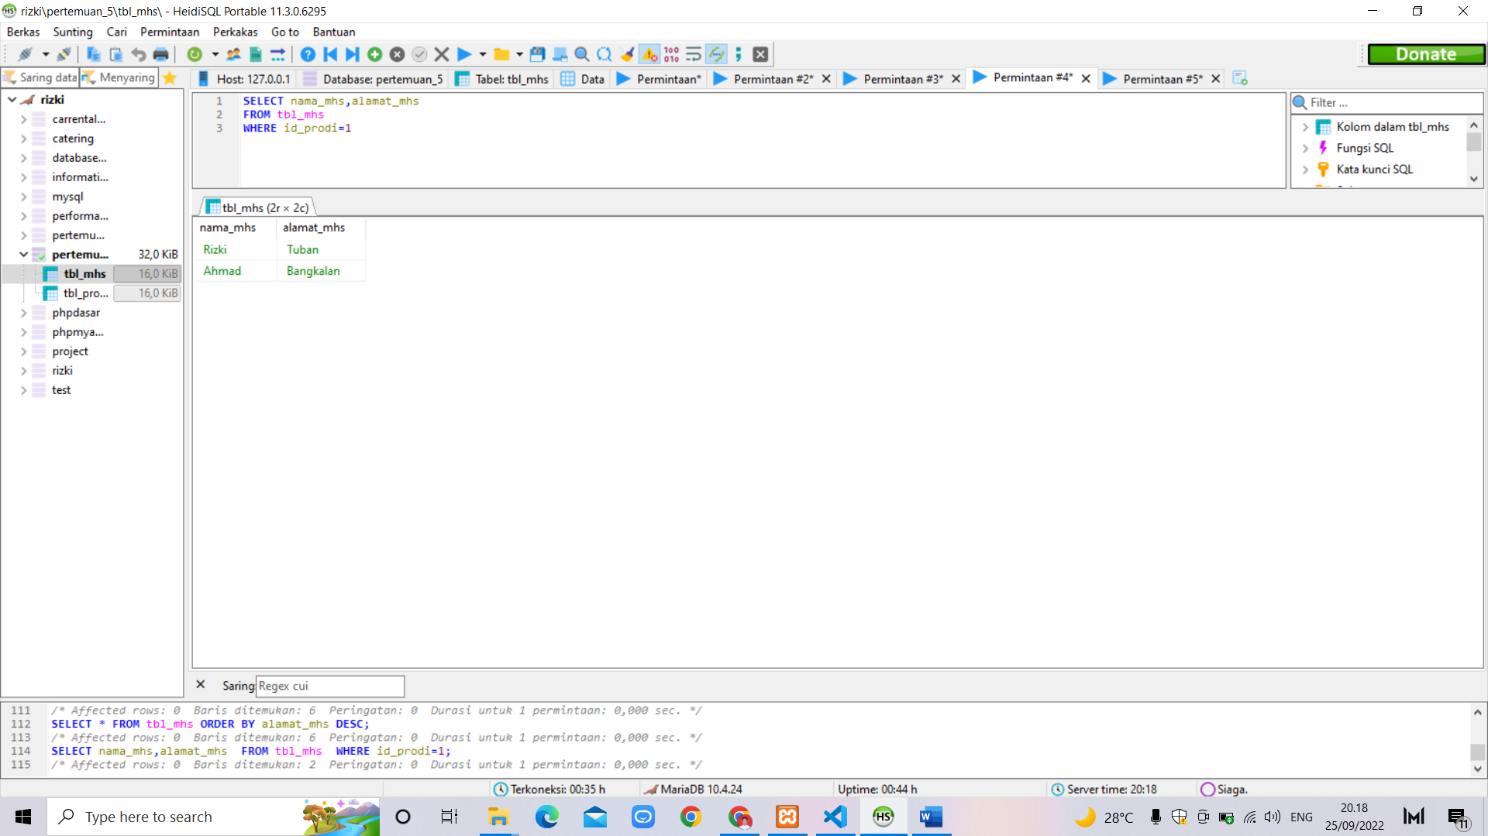

**SELECT** *

**FROM** tbl_prodi

**WHERE** status_prodi="aktif"

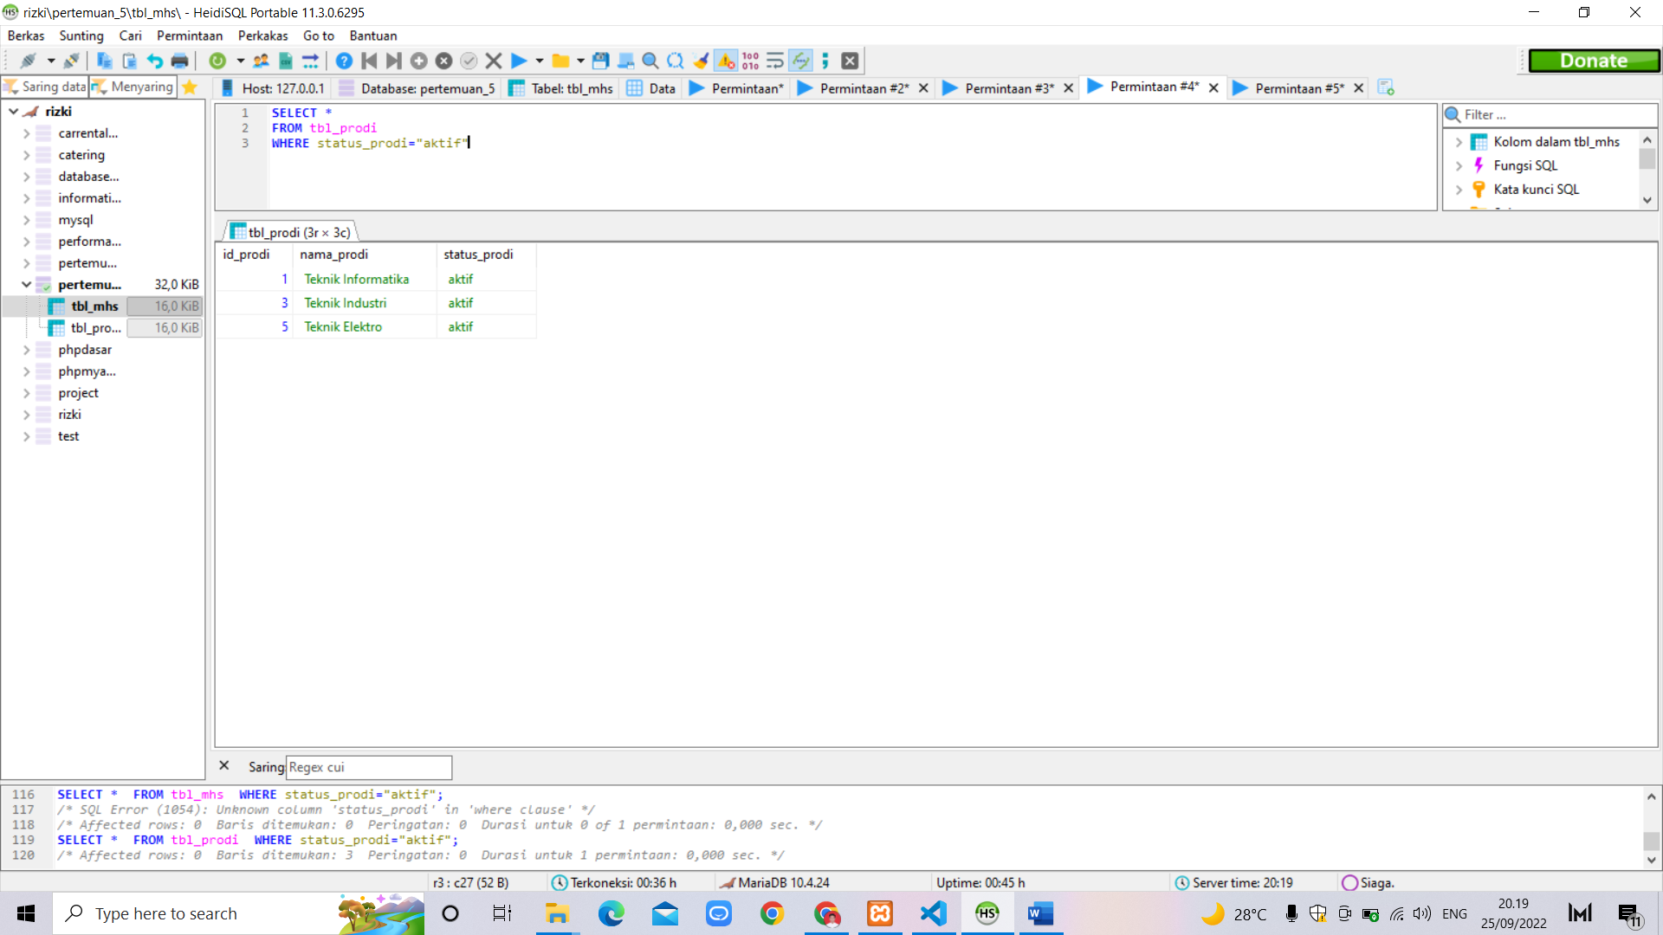

**SELECT** *

**FROM** tbl_mhs, tbl_prodi

**WHERE** tbl_mhs.id_prodi=tbl_prodi.id_prodi

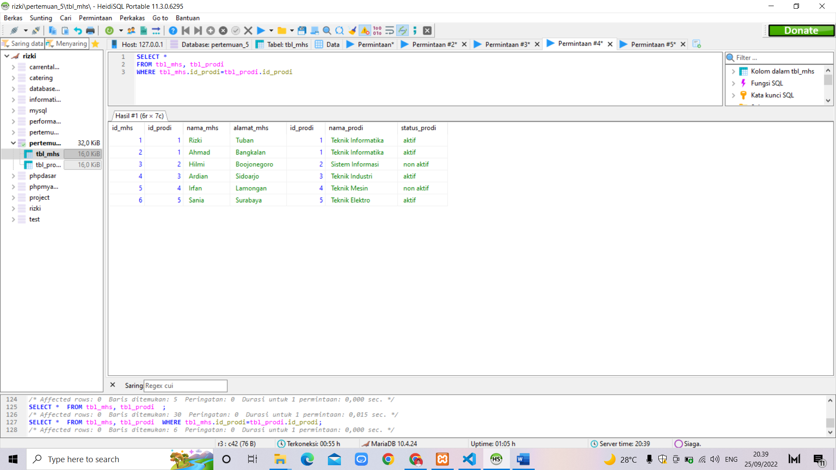

**SELECT** m.nama_mhs, p.nama_prodi

**FROM** tbl_mhs m, tbl_prodi p

**WHERE** m.id_prodi=p.id_prodi

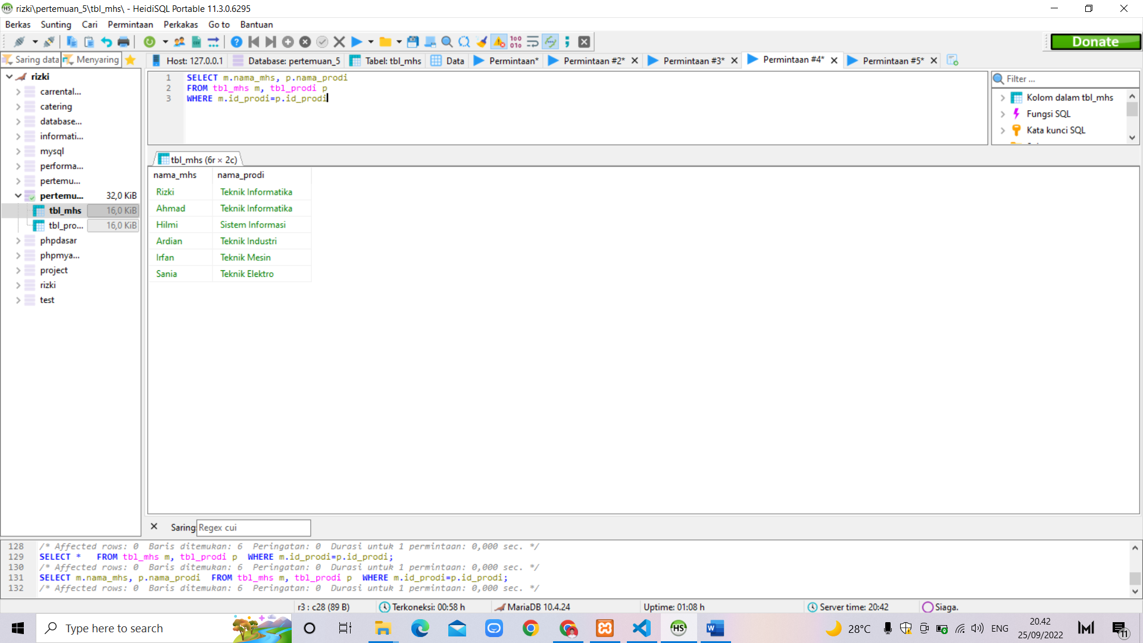

**SELECT** m.nama_mhs, m.alamat_mhs, p.nama_prodi

**FROM** tbl_mhs m, tbl_prodi p

**WHERE** m.id_prodi=p.id_prodi **AND** p.nama_prodi="Teknik Informatika"

**AND** m.alamat_mhs="Tuban"

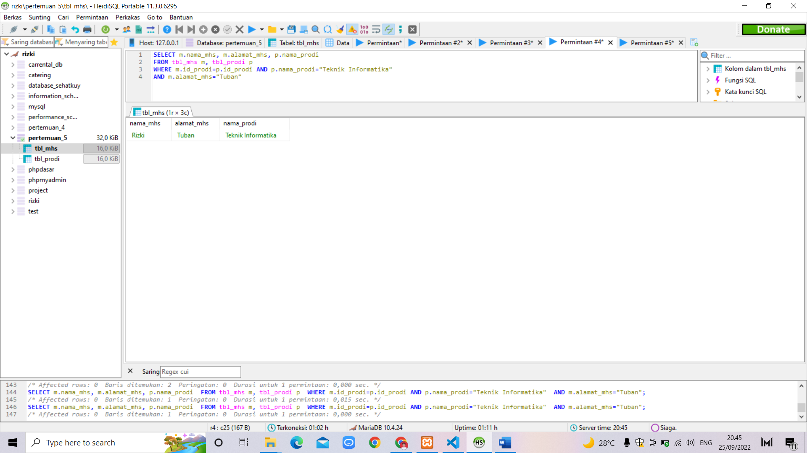

**SELECT** *

**FROM** tbl_prodi

**WHERE** nama_prodi **LIKE** "Teknik%"

